Assignment : 1  
Comparion of Different RDBMS (MySQL, SQLite, Oracle, PostGreSQL)

**What is MySQL ?**

MySQL  is an [relational database management system](https://en.wikipedia.org/wiki/Relational_database_management_system) (RDBMS). Its name is a combination of "My", the name of co-founder [Michael Widenius](https://en.wikipedia.org/wiki/Michael_Widenius)'s daughter My, and "SQL", the acronym for [Structured Query Language](https://en.wikipedia.org/wiki/Structured_Query_Language).

MySQL is [free and open-source software](https://en.wikipedia.org/wiki/Free_and_open-source_software) under the terms of the [GNU General Public License](https://en.wikipedia.org/wiki/GNU_General_Public_License), and is also available under a variety of [proprietary](https://en.wikipedia.org/wiki/Proprietary_software) licenses. MySQL was owned and sponsored by the [Swedish](https://en.wikipedia.org/wiki/Sweden) company [MySQL AB](https://en.wikipedia.org/wiki/MySQL_AB), which was bought by [Sun Microsystems](https://en.wikipedia.org/wiki/Sun_Microsystems) (now [Oracle Corporation](https://en.wikipedia.org/wiki/Oracle_Corporation)). In 2010, when [Oracle acquired Sun](https://en.wikipedia.org/wiki/Acquisition_of_Sun_Microsystems_by_Oracle_Corporation), Widenius [forked](https://en.wikipedia.org/wiki/Fork_(software_development)) the [open-source](https://en.wikipedia.org/wiki/Open-source) MySQL project to create [MariaDB](https://en.wikipedia.org/wiki/MariaDB).

MySQL has stand-alone clients that allow users to interact directly with a MySQL database using SQL, but more often, MySQL is used with other programs to implement applications that need relational database capability. MySQL is a component of the [LAMP](https://en.wikipedia.org/wiki/LAMP_(software_bundle)) [web application](https://en.wikipedia.org/wiki/Web_application) [software stack](https://en.wikipedia.org/wiki/Software_stack) (and [others](https://en.wikipedia.org/wiki/List_of_AMP_packages)), which is an acronym for [*Linux*](https://en.wikipedia.org/wiki/Linux)*,*[*Apache*](https://en.wikipedia.org/wiki/Apache_HTTP_Server)*, MySQL,*[*Perl*](https://en.wikipedia.org/wiki/Perl)*/*[*PHP*](https://en.wikipedia.org/wiki/PHP)*/*[*Python*](https://en.wikipedia.org/wiki/Python_(programming_language)). MySQL is used by many database-driven web applications, including [Drupal](https://en.wikipedia.org/wiki/Drupal), [Joomla](https://en.wikipedia.org/wiki/Joomla), [phpBB](https://en.wikipedia.org/wiki/PhpBB" \o "PhpBB), and [WordPress](https://en.wikipedia.org/wiki/WordPress). MySQL is also used by many popular [websites](https://en.wikipedia.org/wiki/Website), including [Facebook](https://en.wikipedia.org/wiki/Facebook), [Flickr](https://en.wikipedia.org/wiki/Flickr), [MediaWiki](https://en.wikipedia.org/wiki/MediaWiki" \o "MediaWiki), [Twitter](https://en.wikipedia.org/wiki/Twitter), and [YouTube](https://en.wikipedia.org/wiki/YouTube).

**Features of MYSQL**

1. MYSQL language is easy to use as compared to other programming language like C,C++, Java etc. By learning with some basic command we can work , create and interact with Database.
2. MYSQL consist of Data Security layer which protect the data from violator. Also, passwords are encrypted in MYSQL.
3. MYSQL follow Client-Server Architecture where Client request Commands and instructions and Server will produce output as soon as the instruction is matched.
4. MYSQL is free to use under Community version of it. So we can download it from MYSQL website and work on it freely.
5. MYSQL allow transactions to be rolled back, commit and cash recovery.
6. It has low memory leakage problem which increase its memory efficiency.
7. MYSQL version 8.0 provide dual password support , one is a current password and another is secondary password. With the help of this we can create new password.
8. MYSQL provide feature of Partitioning which improve performance of large databases.

**Advantages**

**Reduced Total Cost of Ownership**

Since MySql open source, you can use MySql free and if you want, you can tailor its source code according to your requirement. Most of the companies prefer MySQL because they don't have to pay anything for this excellent product.

**Portability**

MySQL is cross platform database server. It can run on different plateform like Linux, Solaris and Windows etc. It is good choice for those project that target multiple platforms particularly web application. MySql support many plateform with different languages like C, C++, PHP, PERL, JAVA, Python etc.

**Seamless Connectivity**

There are various secure and seamless connection mechanisms are available in order to connect with MySQL server. These connections include named pipes, TCP/IP sockets and UNIX Sockets.

**Rapid Development and Round-the-Clock Uptime**

MySQL comes with the assurance of 24x7 uptime and offers a wide range of high-availability solutions, including specialized cluster servers and master/slave replication configurations. MySQL has a very large developer community which releases regular patches and updates for MySQL.

**Data Security**

MySQL is globally recognize the most secure and reliable database management system used in popular web applications including WordPress, Drupal, Joomla, Facebook and Twitter. Data protected via password and good thing about these passwords is that they are stored in encrypted form and can not break these complex encryption algorithms.

**Disadvantages**

1. MySQL database server has its disadvantages. Some of these disadvantages have been explained below.
2. MySQL lower version (5.0 or less) doesn't support ROLE, COMMIT and stored procedure.
3. MySQL does not support a very large database size as efficiently.
4. MySQL doesn't handle transactions very efficiently and it is prone to data corruption.
5. MySQL doesn't have a good developing and debugging tool compared to other databases.
6. MySQL doesn't support SQL check constraints.

**Applications of MySQL**

1. MySQL is a relational database management system based on SQL – Structured Query Language. The application is used for a wide range of purposes, including data warehousing, e-commerce, and logging applications.
2. The most common use for mySQL however, is for the purpose of a web database. It can be used to store anything from a single record of information to an entire inventory of available products for an online store.
3. In association with a scripting language such as PHP or Perl (both offered on our hosting accounts) it is possible to create websites which will interact in real-time with a mySQL database to rapidly display categorised and searchable information to a website user.

**Architecture of MySQL**

Architecture of MYSQL describes the relation among the different components of MYSQL System. MYSQL follow Client-Server Architecture. It is designed so that end user that is Clients can access the resources from Computer that is server using various networking services. The Architecture of MYSQL contain following major layer’s :

Client

Server

Storage Layer

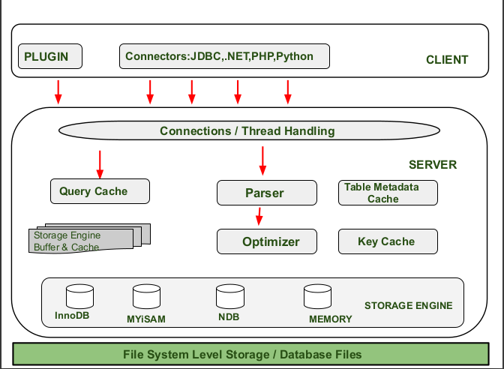

**Client Layer:**

This layer is the topmost layer in the above diagram. The Client give request instructions to the Serve with the help of Client Layer . The Client make request through Command Prompt or through GUI screen by using valid MYSQL commands and expressions .If the Expressions and commands are valid then the output is obtained on the screen.

**Some important services of client layer are :**

1.Connection Handling :

When a client send request to the server and server will accept the request and the client is connected .. When Client is connected to the server at that time , a client get it’s own thread for it’s connection. With the help of this thread all the queries from client side is executed.

2.Authentication :

Authentication is performed on the server side when client is connected to the MYSQL server. Authentication is done with the help of username and password.

3.Security :

After authentication when the client gets connected successfully to MySQL server, the server will check that a particular client has the privileges to issue in certain queries against MySQL server.

**Server Layer:**

The second layer of MYSQL architecture is responsible for all logical functionalities of relational database management system of MYSQL. This Layer of MYSQL System is also known as “Brain of MYSQL Architecture”. When the Client give request instructions to the Server and the server gives the output as soon as the instruction is matched.

**The various sub components of MYSQL server are:**

1.Thread Handling :

When a client send request to the server and server will accept the request and the client is connected . When Client is connected to the server at that time , the client get it’s own thread for it’s connection. This thread is provided by thread handling of Server Layer. Also the queries of client side which is executed by the thread is also handled by Thread Handling module.

2.Parser :

A Parser is a type of Software Component that built a data structure of given input . Before parsing lexical analysis is done i.e. input is broken into number of tokens . After the data is available in the smaller elements parser perform Syntax Analysis , Semantics Analysis after that parse tree is generated as output.

3.Optimizer :

As soon as the parsing is done , various types of optimization techniques are applied at Optimizer Block. These techniques may include rewriting the query, order of scanning of tables and choosing the right indexes to use etc.

4.Query Cache :

Query Cache stores the complete result set for inputted query statement. Even before Parsing , MYSQL Server consult query cache . When client write a query , if the query written by client is identical in the cache then the server simply skip the parsing, optimization and even execution, it just simply display the output from the cache.

5.Buffer and Cache :

Cache and will buffer store the previous query or problem asked by user. When User write a query then it firstly goes to Query Cache then query cache will check that the same query or problem is available in the cache. If the same query is available then it will provide output without interfering Parser, Optimizer.

6.Table Metadata Cache :

The metadata cache is a reserved area of memory used for tracking information on databases, indexes, or objects. The greater the number of open databases, indexes, or objects, the larger the metadata cache size.

7.Key Cache

A key cache is an index entry that uniquely identifies an object in a cache. By default, edge servers cache content based on the entire resource path and a query string.

**Storage Layer:**

This Storage Engine Layer of MYSQL Architecture make it’s unique and most preferable for developer’s . Due to this Layer MYSQL layer is counted as the mostly used RDBMS and is widely used. In MYSQL server , for different situations and requirement’s different types of storage engines are used which are InnoDB ,MYiSAM , NDB ,Memory etc. These storage engines are used as pluggable storage engineer where tables created by user are plugged with them.

**Scalability**

MYSQL use multithreading which makes it Scalable. It can handle any amount of data .The default file size limit is 4 GB, but we can increase it according to our need.

To meet the sustained performance and scalability of ever increasing user, query and data loads MySQL Enterprise Edition provides the MySQL Thread Pool. The Thread Pool provides a highly scalable thread-handling model designed to reduce overhead in managing client connections and statement execution threads.

MYSQL is very flexible because it supports large number of embedded systems.

**Performance**

MYSQL is considered as one of the fast database. It’s fastness is determined on the basis of large number of benchmark tests.

MySQL uses indexes as a book index or roadmap to quickly find values for a given query. Without indexes, MySQL will scan the entire table row by row to find the relevant data. Thus, index optimization is aimed at speeding up data retrieval.

MYSQL is compatible to run on various operating system such as Windows, MacOS , Linux etc.

**How Does MySQL Work?**

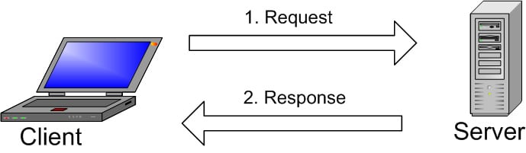

How MySQL Works ?

The image explains the basic structure of the client-server structure. One or more devices (clients) connect to a server through a specific network. Every client can make a request from the graphical user interface (GUI) on their screens, and the server will produce the desired output, as long as both ends understand the instruction. Without getting too technical, the main processes taking place in a MySQL environment are the same, which are:

1. MySQL creates a database for storing and manipulating data, defining the relationship of each table.
2. Clients can make requests by typing specific SQL statements on MySQL.
3. The server application will respond with the requested information and it will appear on the clients’ side.

That’s pretty much it. From the clients’ side, they usually emphasize which MySQL GUI to use. The lighter and more user-friendly the GUI is, the faster and easier their data management activities will be. Some of the most popular MySQL GUIs are MySQL WorkBench, SequelPro, DBVisualizer, and the Navicat DB Admin Tool. Some of them are free, while some are commercial, some run exclusively for macOS, and some are compatible with major operating systems. Clients should choose the GUI depending on their needs. For web database management, including a WordPress site, the most obvious go-to is phpMyAdmin.

**What is Oracle?**

Oracle database is a relational database management system (RDBMS) from Oracle Corporation. This article will explain a complete overview of the Oracle database, features, history, and editions. Before discussing the oracle, we will first need to know about the database.

**What is the Oracle database?**

Oracle database is a relational database management system. It is also called OracleDB, or simply Oracle. It is produced and marketed by Oracle Corporation. It was created in 1977 by Lawrence Ellison and other engineers. It is one of the most popular relational database engines in the IT market for storing, organizing, and retrieving data. Oracle database was the first DB that designed for enterprise grid computing and data warehousing.

Oracle database is compatible with a wide range of platforms such as Windows, UNIX, Linux, and macOS. It supports several operating systems like IBM AIX, HP-UX, Linux, Microsoft Windows Server, Solaris, SunOS, macOS, etc. In the late 1990s, Oracle began supporting open platforms like GNU/Linux.

**The following is a list of Oracle database editions in order of priority:**

1. **Enterprise Edition:** It is the most robust and secure edition. It offers all features, including superior performance and security.
2. **Standard Edition:** It provides the base functionality for users that do not require Enterprise Edition's robust package.
3. **Express Edition (XE):** It is the lightweight, free and limited Windows, and Linux edition.
4. **Oracle Lite:** It is designed for mobile devices.
5. **Personal Edition:** It's comparable to the Enterprise Edition but without the Oracle Real Application Clusters feature.

**Oracle Database Features**

**Availability**: It is never offline or out of service that means supported 24*7 availability of the database. It provides high availability of databases because of the Oracle Data Guard functionality. This functionality allows using of the secondary database as a copy of the primary database during any failure. As a result, all normal processes such as backups and partial failures do not interrupt the database from being used.

**Security:** Oracle has a mechanism for controlling and accessing the database to prevent unauthorized access. It provides high security because of the Oracle Advanced Security features. It offers two solutions to protect databases that are TDE (Transparent Data Encryption) and Data Redaction. TDE supports data encryption both at the source and after export. Redaction is performed at the application level. Oracle has some other security features like Oracle Database Vault that regulates user privileges and Oracle Label Security.

**Scalability:** It provides features like RAC (Real Application Cluster) and Portability, which makes an Oracle database scalable based on usage. In a clustered environment, it includes capabilities such as rolling instance migrations, performing upgrades, maintaining application continuity, quality of service management, etc.

**Performance:** Oracle provides performance optimization tools such as Oracle Advanced Compression, Oracle Database In-Memory, Oracle Real Application Testing, and Oracle Times Ten Application-Tier Database Cache. Their main objective is to improve system performance to the highest possible level.

**Analytics:** Oracle has the following solutions in the field of analytics:

* **OLAP (Oracle Analytic Processing):** It is an implementation of Oracle for doing complicated analytical calculations on business data.
* **Oracle Advanced Analytics:** It is a technical combination of Oracle R Enterprise and Oracle Data Mining that assists customers in determining predictive business models through data and text mining, as well as statistical data computation.

**Management:** Oracle Multitenant is a database management tool that combines a single container database with many pluggable databases in a consolidated design.

**Advantages of Oracle Database**

**Performance:** Oracle has procedures and principles that help us to get high levels of database performance. We can increase query execution time and operations with the use of performance optimization techniques in its database. This technique helps to retrieve and alter data faster.

**Portability:** The Oracle database can be ported on all different platforms than any of its competitors. We can use this database on around 20 networking protocols as well as over 100 hardware platforms.

**Backup and Recovery:** It is always better to take a proper backup of your entire oracle online backup and recovery. The Oracle database makes it easy to accomplish recovery quickly by using the. RMAN (Recovery Manager) functionality. It can recover or restore database files during downtime or outages. It can be used for online backups, archived backups, and continuous archiving.

**PL/SQL:** One of the greatest benefits of using the Oracle database is to support PL/SQL extension for procedural programming.

**Multiple Database:** Oracle database allows several database instances management on a single server. It provides an instance caging approach for managing CPU allocations on a server hosting database instances. The database resource management and instance caging can work together to manage services across multiple instances.

**Flashback Technology:** This advantage comes with the recent Oracle version. It allows us to recover those data that are incorrectly deleted or lost by human errors like accidental deletion of valuable data, deleting the wrong data, or dropping the table.

**Disadvantages of Oracle Database**

**Complexity:** Oracle is not recommended to use when the users are not technically savvy and have limited technical skills required to deal with the Oracle Database. It is also not advised to use if the company is looking for a database with limited functionality and easy to use.

**Cost:** The price of Oracle products is very high in comparison to other databases. Therefore users are more likely to choose other less expensive options such as MS SQL Server, MySQL, etc.

**Difficult to manage:** Oracle databases are often much more complex and difficult in terms of the management of certain activities.

**Applications**

Oracle Applications term refers to the non-database and non-middleware parts. The suite of applications includes enterprise resource planning, enterprise performance management, supply chain & manufacturing, human capital management, and advertising and customer experience.

**Applications of different Oracle Database Editions :**

**Oracle Enterprise Resource Planning (ERP)**

Oracle Cloud ERP is a cloud-based ERP software application suite that manages enterprise functions including accounting, project management, etc.

**Oracle Enterprise Performance Management (EPM)**

Oracle Cloud EPM is a cloud-based EPM software application suite that manages enterprise operational processes including planning, budgeting, and reporting.

**Oracle Human Capital Management (HCM)**

Oracle Cloud HCM is a cloud-based HCM software application suite that manages global HR, talent, and workforce management. Oracle Cloud HCM was released in 2011 as a part of Oracle Fusion Applications.

**Oracle Supply Chain Management (SCM)**

Oracle Cloud SCM, also known as Oracle Supply Chain & Manufacturing, is a cloud-based SCM software application suite used by companies to build and manage intelligent supply chains. This includes support for procurement, order management, manufacturing, product lifecycle management, etc.

**Oracle Advertising and Customer Experience (CX)**

Oracle Advertising and Customer Experience (CX) is a cloud-based application suite that includes tools for advertising, marketing, sales, e-commerce, and customer service.

**Oracle Architecture**

**The oracle database architecture consists of:**

* Memory structure(Instances)
* Database system
* Processes

**Oracle Instances**

**The instance is a collection of two things:**

**SGA:** It stands for System Global Area. It is a shared memory area. Whenever a database instance starts, some memory gets allocated and that memory is termed SGA. Along with memory allocation, one or more background processes will. SGA is used to store data as well as control information about one database instance through its various subcomponents. Various Components are:

* **Database buffer cache:** The Buffer Cache is a portion of the SGA that stores copies of data blocks read from datafiles. It is used to cache frequently accessed data blocks, reducing the number of disks I/Os required to access the data. This can improve performance by reducing disk I/O time and increasing the speed of data retrieval.
* **Redo log Buffer:** The most crucial structure for recovery operations is the redo log, which consists of two or more preallocated files that store all changes made to the database as they occur. Every instance of an Oracle Database has an associated redo log to protect the database in case of an instance failure.
* **Java pool:** The Java Pool is an optional portion of the SGA that is used by Java Virtual Machine (JVM) and related components. It is used to store Java-related data structures, such as Java classes and objects. This pool is used when the Oracle Database is configured to run Java applications or when using Oracle JVM.
* **Large Pool:** The Large Pool is an optional portion of the SGA that can be used for large memory allocation, such as backup and restore operations and I/O server processes. It is typically used to improve the performance of these operations by reducing the amount of disk I/O required.
* **Shared pool:** The Shared Pool is a portion of the SGA that contains shared memory structures, such as shared SQL and PL/SQL areas. It is used to store the parsed representation of SQL statements, execution plans, and PL/SQL program units. This allows for the efficient reuse of frequently executed statements, reducing the need for reparsing and improving performance.

**Background processes:** Oracle has a collection of processes that are called background processes. These processes are responsible for managing memory, performing I/O operations, and other maintenance activities. Following are some important background processes that are required:

* **System Monitor Process (SMON):** These processes are responsible for performing system-level recovery and maintenance activities.
* Process Monitor Process (PMON): The task of these processes is to monitor other background processes.
* **Database Writer Process (DBWR):** This process performs the task of writing data blocks from the Database Buffer Cache (present in SGA) to physical data files(Present in the Database system).
* **Log Writer Process (LGWR):** This process writes the Redo blocks from Redo Log Buffer (present in SGA) to Redo Log Files(present in the Database system).
* **CheckPoint (CKPT):** This process maintains data files and control files with the most recent checkpoint information.

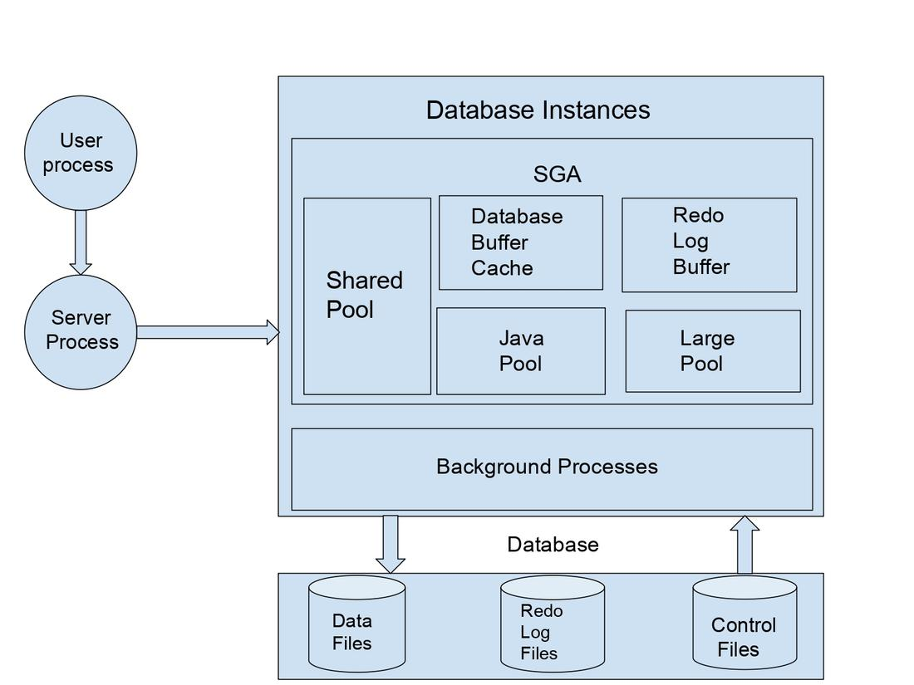

**Database System**

The database system is suited to the storage system of a computer. The Database system is simply the storage of files. There are three categories of files that are situated in the database system and those are:-

* **Data files:** These files hold the actual data in the database.
* **Redo log files:** These files are used to hold the changes made in the database. Redo log files can be utilized during the database recovery process to retrieve the original information.
* **Control files:** It is a binary file that holds database status-related information like Database Name, Data File, and Redo Log file Names, File Locations, and Log Sequence Number.

There are other categories of files that contribute to database management.

* **Parameter file:** This file contains the parameters which define the way the database is expected to start up.
* **Password file:** This file holds the user passwords and thus maintains the security of databases.

**Processes**

There are two types of processes:

* **User process:** It is also known as the client process The user actually connects to the instance with the help of user processes.

the user process is stabilized when the user sends a connection request to the oracle server.

* **Server process:** The server Process connects the user to the database and performs the activities on the client’s behalf as executing SQL statements or retrieving data from the database.

**Scalability**

Oracle Sharding provides the ability to scale horizontally by dividing a single logical database across multiple, independent physical databases.

The original concept of scaling horizontally involved using clusters of smaller computers combined with shared storage accessed simultaneously by processes running on all compute nodes of the cluster. When you need to grow, just add another compute node to the cluster and expand the shared storage pool.

Scaling vertically means running a database on a single server, then moving to progressively larger and larger servers to handle larger amounts of data and workload. Oracle Database can run on anything from the smallest Virtual Machine to the largest Virtual Machine possible as well as massive bare-metal servers, with 4,8 and even 16-socket servers.

Scaling vertically involves MOVING the database to a larger machine, whether that’s a larger Virtual Machine or a larger Physical Machine.

**Performance**

In Oracle, Performance tuning is the process of administering a database to improve performance. Performance tuning in Oracle databases includes**optimizing SQL statements** and query execution plans so that the requests can be completed more efficiently.

**Database tuning is performed in two phases: proactively and reactively.**

In the proactive tuning phase, you must perform tuning tasks as part of your daily database maintenance routine, such as reviewing ADDM analysis and findings, monitoring the real-time performance of the database, and responding to alerts.

In the reactive tuning phase, you must respond to issues reported by users, such as performance problems that may occur for only a short duration of time, or performance degradation to the database over a period of time.

SQL tuning is an iterative process to identify, tune, and improve the efficiency of high-load SQL statements.

**Working of Oracle Database**

Oracle Database, like most RDBMS, uses the standardized programming language SQL (Structured Query Language) to create database structures, manage records, perform actions, or retrieve contained data. Oracle’s own programming language PL/SQL, in turn, is closely related to SQL and lets you add Oracle programming extensions to SQL. To structure the databases, Oracle uses row and column tables in which data points are linked via attributes. This makes cross-table access efficient and time effective.

The architecture of Oracle database systems consists of a database for storing database files, one or more database instances for data management, and one or more listener processes that connect database clients to database instances. Here, logical and physical data structures are separated into Oracle databases. These include physical and logical storage structures:

Physical storage structures: Data files, control files (with database metadata), and red-log files (for documenting changes).

Logical storage structures: Data blocks and tables, extents (for grouping logical data blocks), segments (extent records) and tablespaces (logical segment containers).

The clear structure of Oracle databases ensures that data is reliably managed with maximum security measures thanks to data and network encryption, strict authentication, authorization, and authorization analyses. In addition, Oracle supports Java and retrieves Java programming with PL/SQL.

**What is Microsoft SQL Server ?**

Microsoft SQL Server is a relational database management system developed by Microsoft. As a database server, it is a software product with the primary function of storing and retrieving data as requested by other software applications—which may run either on the same computer or on another computer across a network (including the Internet). Microsoft markets at least a dozen different editions of Microsoft SQL Server, aimed at different audiences and for workloads ranging from small single-machine applications to large Internet-facing applications with many concurrent users.

**Microsoft SQL Server 2022 Features**

**SQL Server Database Engine :** SQL Server Database Engine includes the Database Engine, the core service for storing, processing, and securing data, replication, full-text search, tools for managing relational and XML data, in database analytics integration, and PolyBase integration for access to heterogeneous data sources, and Machine Learning Services to run Python and R scripts with relational data.

**Analysis Services :** It includes the tools for creating and managing online analytical processing (OLAP) and data mining applications.

**Reporting Services :** It includes server and client components for creating, managing, and deploying tabular, matrix, graphical, and free-form reports. Reporting Services is also an extensible platform that you can use to develop report applications.

**Integration Services :** It is a set of graphical tools and programmable objects for moving, copying, and transforming data. It also includes the Data Quality Services (DQS) component for Integration Services.

**Master Data Services (MDS)** **:** It is the SQL Server solution for master data management. MDS can be configured to manage any domain (products, customers, accounts) and includes hierarchies, granular security, transactions, data versioning, and business rules, as well as an Add-in for Excel that can be used to manage data.

**Machine Learning Services (In-Database) :** It supports distributed, scalable machine learning solutions using enterprise data sources. In SQL Server 2016, the R language was supported. SQL Server 2022 (16.x) supports R and Python.

**Data Virtualization with PolyBase :** Query different types of data on different types of data sources from SQL Server.

**Azure connected services :** SQL Server 2022 (16.x) extends Azure connected services and features including Azure Synapse Link, Microsoft Purview access policies, Azure extension for SQL Server, pay-as-you-go billing, and the link feature for SQL Managed Instance.

**Advantage of Microsoft SQL Server**

**Increase Data Security:** It ensure the security of database especially with MS-SQL Server database administrator service.

**Ease of Configure:** Unlike another database management system the installation and configuration is easier.

**Optimized Data Storage:** We don't require any other data storage for the same database while using different device also.It also allows the troubleshooting and maintenance of data easily.

**Data Recover Support:** If the power interruption or server shutdowns occurs data may be corrupted so Microsoft SQL Server eliminates the risk of losing data by having features for data recovery and restoration.

**Disadvantages of Microsoft SQL Server**

**Cost:** If you want some more advance features and database application you can make investments for higher version also.

**Restricted Compatibility:** You can make some additional investments in Microsoft Software if you want to used little microsoft infrastructure but they will allow you to use Microsoft SQL Server on your platform.

**Hardware Restriction:** You might need a newer machine if your hardware is of older version because newer versions of Microsoft SQL Server need advanced technologies to run.

**Applications of SQL Server**

1. To create databases.
2. To maintain databases.
3. To analyze the data through SQL Server Analysis Services (SSAS).
4. To generate reports through SQL Server Reporting Services (SSRS).
5. To carry out ETL operations through SQL Server Integration Services (SSIS).

**General Architecture**

**Client −** Where the request initiated.

**Query −** SQL query which is high level language.

**Logical Units −** Keywords, expressions and operators, etc.

**N/W Packets −** Network related code.

**Protocols −** In SQL Server we have 4 protocols.

* Shared memory (for local connections and troubleshooting purpose).
* Named pipes (for connections which are in LAN connectivity).
* TCP/IP (for connections which are in WAN connectivity).
* VIA-Virtual Interface Adapter (requires special hardware to set up by vendor and also deprecated from SQL 2012 version).

**Server −** Where SQL Services got installed and databases reside.

**Relational Engine −** This is where real execution will be done. It contains Query parser, Query optimizer and Query executor.

**Query Parser (Command Parser) and Compiler (Translator) −** This will check syntax of the query and it will convert the query to machine language.

**Query Optimizer −** It will prepare the execution plan as output by taking query, statistics and Algebrizer tree as input.

**Execution Plan −** It is like a roadmap, which contains the order of all the steps to be performed as part of the query execution.

**Query Executor −** This is where the query will be executed step by step with the help of execution plan and also the storage engine will be contacted.

**Storage Engine −** It is responsible for storage and retrieval of data on the storage system (disk, SAN, etc), data manipulation, locking and managing transactions.

**SQL OS −** This lies between the host machine (Windows OS) and SQL Server. All the activities performed on database engine are taken care of by SQL OS.

**Checkpoint Process −** Checkpoint is an internal process that writes all dirty pages from Buffer Cache to Physical disk. Apart from this, it also writes the log records from log buffer to physical file.

**Checkpoints in SQL Server**

In SQL Server 2012 there are four types of checkpoints −

**Automatic −** This is the most common checkpoint which runs as a process in the background to make sure SQL Server Database can be recovered in the time limit.  
**Indirect –** It runs in the background but to meet a user-specified target recovery time for the specific database where the option has been configured.   
**Manual −** This one runs just like any other T-SQL statement, once you issue checkpoint command it will run to its completion. Manual checkpoint runs for your current database only.

**Internal −** As a user you can’t control internal checkpoint. Issued on specific operations such as

* Shutdown initiates a checkpoint operation on all databases except when shutdown is not clean (shutdown with nowait).
* If the recovery model gets changed from Full\Bulk-logged to Simple.
* While taking backup of the database.
* Alter database command to add or remove a data\log file also initiates a checkpoint.
* Checkpoint also takes place when the recovery model of the DB is bulk-logged and a minimally logged operation is performed.

**Lazy Writer Process −** Lazy writer will push dirty pages to disk for an entirely different reason, because it needs to free up memory in the buffer pool. This happens when SQL server comes under memory pressure.

**Memory Architecture**

**Following are some of the salient features of memory architecture**.

* One of the primary design goals of all database software is to minimize disk I/O because disk reads and writes are among the most resource-intensive operations.
* Memory in windows can be called with Virtual Address Space, shared by Kernel mode and User mode.
* SQL Server "User address space" is broken into two regions: MemToLeave and Buffer Pool.
* Size of MemToLeave (MTL) and Buffer Pool (BPool) is determined by SQL Server during startup.
* Buffer management is a key component in achieving I/O highly efficiency. The buffer management component consists of two mechanisms: the buffer manager to access and update database pages, and the buffer pool to reduce database file I/O.
* The buffer pool is further divided into multiple sections. The most important ones being the buffer cache (also referred to as data cache) and procedure cache.
* Procedure cache keeps the stored procedure and query execution plans to minimize the number of times that query plans have to be generated.

Other portions of buffer pool include −

**System level data structures −** Holds SQL Server instance level data about databases and locks.

**Log cache −** Reserved for reading and writing transaction log pages.

**Connection context −** Each connection to the instance has a small area of memory to record the current state of the connection.

**Stack space −** Windows allocates stack space for each thread started by SQL Server.

**Data File Architecture**

**Data File architecture has the following components −**

**File Groups**

Database files can be grouped together in file groups for allocation and administration purposes. No file can be a member of more than one file group. Log files are never part of a file group.

There are two types of file groups in SQL Server, Primary and User-defined. Primary file group contains the primary data file and any other files not specifically assigned to another file group. All pages for the system tables are allocated in the primary file group.

User-defined file groups are any file groups specified using the file group keyword in create database or alter database statement. By default, primary file group is the default file group.

**Files**

Databases have three types of files –

**Primary data file** is the starting point of the database and points to the other files in the database.

Every database has one primary data file. We can give any extension for the primary data file but the recommended extension is .mdf.

**Secondary data file** is a file other than the primary data file in that database. Some databases may have multiple secondary data files. Some databases may not have a single secondary data file. Recommended extension for secondary data file is .ndf.

**Log files** hold all of the log information used to recover the database. Database must have at least one log file. We can have multiple log files for one database. The recommended extension for log file is .ldf.

The location of all the files in a database are recorded in both master database and the primary file for the database.

**Extents**

Extents are basic unit in which space is allocated to tables and indexes. An extent is 8 contiguous pages or 64KB. SQL Server has two types of extents - Uniform and Mixed.

**Pages**

It is the fundamental unit of data storage in MS SQL Server. The size of the page is 8KB. The start of each page is 96 byte header used to store system information such as type of page, amount of free space on the page and object id of the object owning the page.

**There are 9 types of data pages in SQL Server.**

* Data − Data rows with all data except text, ntext and image data.
* Index − Index entries.
* Text\Image − Text, image and ntext data.
* GAM − Information about allocated extents.
* SGAM − Information about allocated extents at system level.
* Page Free Space (PFS) − Information about free space available on pages.
* Index Allocation Map (IAM) − Information about extents used by a table or index.
* Bulk Changed Map (BCM) − Information about extents modified by bulk operations since the last backup log statement.
* Differential Changed Map (DCM) − Information about extents that have changed since the last backup database statement.

**Log File Architecture**

The SQL Server transaction log operates logically as if the transaction log is a string of log records. Each log record is identified by Log Sequence Number (LSN). Each log record contains the ID of the transaction that it belongs to.

Log records for data modifications record either the logical operation performed or they record the before and after images of the modified data. The before image is a copy of the data before the operation is performed; the after image is a copy of the data after the operation has been performed.

**The steps to recover an operation depend on the type of log record −**

Logical operation logged.

* To roll the logical operation forward, the operation is performed again.
* To roll the logical operation back, the reverse logical operation is performed.

Before and after image logged.

* To roll the operation forward, the after image is applied.
* To roll the operation back, the before image is applied.

**Different types of operations are recorded in the transaction log. These operations include −**

* The start and end of each transaction.
* Every data modification (insert, update, or delete). This includes changes by system stored procedures or data definition language (DDL) statements to any table, including system tables.
* Every extent and page allocation or de allocation.
* Creating or dropping a table or index.

**Scalability**

SQL Server 2016 (13.x) contains scalability enhancements to the on-disk storage for memory-optimized tables.

**Multiple threads to persist memory-optimized tables**

SQL Server 2014 (12.x) had a single offline checkpoint thread that scanned the transaction log for changes to memory-optimized tables and persisted them in checkpoint files (such as data and delta files). In machines with a larger number of cores, the single offline checkpoint thread could fall behind.

Starting with SQL Server 2016 (13.x), there are multiple concurrent threads responsible to persist changes to memory-optimized tables.

**Monitor and Tune for Performance**

The goal of monitoring databases is to assess how a server is performing. Effective monitoring involves taking periodic snapshots of current performance to isolate processes that are causing problems, and gathering data continuously over time to track performance trends.

Ongoing evaluation of the database performance helps you minimize response times and maximize throughput, yielding optimal performance. Efficient network traffic, disk I/O, and CPU usage are key to peak performance. You need to thoroughly analyze the application requirements, understand the logical and physical structure of the data, assess database usage, and negotiate tradeoffs between conflicting uses such as online transaction processing (OLTP) versus decision support.

**What is PostGreSQL**

PostgreSQL is a powerful, open source object-relational database system that uses and extends the SQL language combined with many features that safely store and scale the most complicated data workloads.

PostgreSQL has earned a strong reputation for its proven architecture, reliability, data integrity, robust feature set, extensibility, and the dedication of the open source community behind the software to consistently deliver performant and innovative solutions.

PostgreSQL development was started in 1986 as a follow-up to INGRES (an open-source SQL relational database project begun in the early 1970s), Postgres was developed by Michael Stonebraker, a computer science professor at University of California in Berkeley. In 1996, the project added support for SQL and it was renamed to PostgreSQL.

**Features of PostgreSQL**

* It allows administrators to build fault-tolerant environment by protecting data integrity.
* Compatible with various platforms using all major languages and middleware.
* It offers a most sophisticated locking mechanism.
* Support for multi-version concurrency control.
* Mature Server-Side Programming Functionality.
* Object-oriented and Compliant with the ANSI SQL standard.
* Full support for client-server network architecture.
* Log-based and trigger-based replication SSL.
* Standby server and high availability.
* Support for JSON allows linking with other data stores like NoSQL which act as a federated hub for polyglot databases.

**Advantages of PostgreSQL**

* PostgreSQL can run dynamic websites and web apps as a LAMP stack option.
* PostgreSQL source code is freely available under an open source license. This allows you the freedom to use, modify, and implement it as per your business needs.
* PostgreSQL supports geographic objects so you can use it for location-based services and geographic information systems.
* To learn Postgres, you don’t need much training as its easy to use.
* Low maintenance and administration for both embedded and enterprise use of PostgreSQL.

**Disadvantages of PostgreSQL**

* Postgres is not owned by one organization. So, it has had trouble getting its name out there despite being fully featured and comparable to other DBMS systems
* Changes made for speed improvement requires more work than MySQL as PostgreSQL focuses on compatibility
* Many open source apps support MySQL, but may not support PostgreSQL
* On performance metrics, it is slower than MySQL.

**Applications of PostgreSQL**

**Financial Industry**

PostgreSQL is an ideal DBMS system for the financial industry. Moreover, It is fully ACID compliant which makes it an ideal choice for OLTP (Online Transaction Processing).

**Government GIS data**

PostgreSQL offers powerful GIS which is called “PostGIS”. This extension provides hundreds of functions to process geometric data in different formats. PostGIS is highly standard compliant.

**Manufacturing**

Nowadays, industrial manufacturers also using PostgreSQL to speed up their overall business process. It also helps them to optimize supply chain performance by using this open-source DBMS as storage backend.

**Web technology and NoSQL**

If your website requires to deal with hundreds or even thousands request per second at that time, scalability is a surely big issue. Here, Postgre proves the best solution.

**Scientific data**

You need to generate terabytes of data if you are working on research and scientific project. Therefore, it is important to handle in the most efficient way as possible. For that, PostgreSQL offers wonderful analytical capabilities and powerful SQL engine.

**Architecture of PostgreSQL**

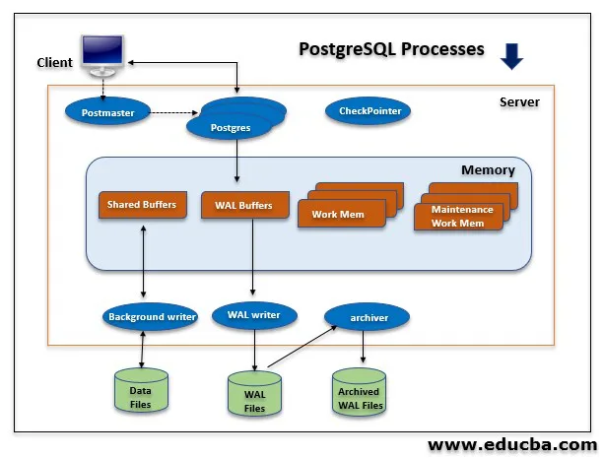

**1. Shared Memory**

Shared memory refers to the memory reserved for transactional, and another log catches. Shared memory consist of the following components:

Shared Buffers : The default value of shared buffers in older version is 32 megabytes and the later default value of shared buffers is 128 megabytes. shared buffers value is 25% of total memory. The purpose of shared buffers is to minimize server DISK IO.

WAL Buffers : WAL buffers temporarily store changes in the database. The minimum value of shared buffers is 32KB. If we set this parameter as wal_buffers = -1, it will set based on shared_buffers.

Work Memory : It Sets the specific memory to per client connections to be used by internal sort of operations and hash tables to writing data into temporary disk files.The default value of work memory in the older version is 1 megabyte and the later default value of work memory is 4 megabytes.

Maintenance Work Memory : We need to specify the maximum amount of memory for database maintenance operations such as VACUUM, ANALYZE, ALTER TABLE, CREATE INDEX, ADD FOREIGN KEY, etc.

**2. Background Processes**

Below are the background processes of PostgreSQL.

* **Background Writer process:**It will keep logs and backup information up to date.
* **WAL Writer:** This process writes and flushes the WAL data on the WAL buffer to persistent storage periodically.
* **Logging Collector:** This process also called a logger. It will write a WAL buffer to the WAL file.
* **autovacuum Launcher:** When autovacuum is enabled, this process has the autovacuum daemon’s responsibility to carry vacuum operations on bloated tables.
* **Archiver:** If we enable archive mode, this process has the responsibility to copy the WAL log files to a specified directory.
* **Stats Collector:** In this process, Statistics information like pg_stat_activity and pg_stat_database is collected. Information is passed from the stats collector via temporary files to requesting processes.
* **Checkpointer Process:**This process’s actual work is when a checkpoint occurs, it will write dirty buffer into a file.
* **Checkpointer :**Checkpointer will write all dirty pages from memory to disk and clean the shared buffer area. If the [PostgreSQL database](https://www.educba.com/postgresql-database/) is crashed, we can measure data loss between the last checkpoint time and PostgreSQL stopped time.

The checkpoint will occur in the following scenarios:

* The pages are dirty.
* Starting and restarting the DB server.
* Issue of the commit.
* Starting the database backup.
* Stopping the database backup.
* Creation of the database.

**3. Data Files / Data Directory Structure**

* PostgreSQL consists of multiple databases this is called a database cluster. When we initialize PostgreSQL database template0, template1 and Postgres databases are created.
* Template0 and template1 are template databases for new database creation of user it contains the system catalog tables.
* The user database will be created by cloning the template1 database.
* PGDATA directory contains several subdirectories, and control files are as follows.
* **pg_version:** It contains database version information.
* **Base:** Containing database subdirectories.
* **Global:** Containing cluster wise tables such as pg_user.
* **pg_clog:** Containing transaction commits status data.
* **pg_multixact:** Containing multi transaction status data (used for shared row locks).
* **pg_notify:**Containing LISTEN/NOTIFY status data.
* **pg_serial:** Containing information about committed serializable transactions.

**Scalability**

The PostgreSQL database supports **vertical scalability** and can run on bigger and faster machines to increase the performance. But when it comes to horizontal scalability, it does not have many options. However it does provide some truly feasible options to achieve that.

**Performance**

PostgreSQL **supports both non-relational and relational data types**. It has been called one of the most compliant, stable and mature relational databases available today and can easily handle complex queries that makes its more reliable and efficient.

PostgreSQL is known in the market for performing complicated, high-volume data operations. it allows you to define index types, data types, and functional languages on top of storing information in the form of tables and columns that make it high in performance.

**How Does PostgreSQL Work?**

**PostgreSQL** uses a client-server model where the client and the server can reside on different hosts in a networked environment. The server program manages the database files, accepts connections to the database from client applications. It can handle multiple concurrent connections from clients by “**forking**” a new process for each connection. It executes database requests from clients and sends the results back to the clients. Remote clients can connect over the network or internet to the server.

Valid client programs include text-oriented tools that ship with PostgreSQL, a graphical tool, or applications developed using other programming languages.

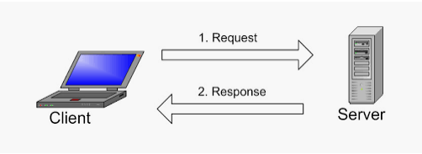

PostgreSQL Server and Client Requests

**What is Sybase ?**

**Sybase, Inc.** was an [enterprise software](https://en.wikipedia.org/wiki/Enterprise_software) and services company. The company produced software relating to [relational databases](https://en.wikipedia.org/wiki/Relational_database), with facilities located in California and [Massachusetts](https://en.wikipedia.org/wiki/Massachusetts). Sybase was acquired by [SAP](https://en.wikipedia.org/wiki/SAP_AG) in 2010; SAP ceased using the Sybase name in 2014.

Sybase database servers consist of a data server and a backup server. There are two processes of the Sybase database server, whereas an Oracle instance has five mandatory processes: SMON (System Monitor), PMON (Process Monitor), LGWR (Log Writer), DBWR (Database Writer), and CKPT (Checkpoint). The optional ARCH archive process writes filled redo logs to the archive log location(s). In an Oracle Real Application Cluster (RAC), the various ARCH processes can be utilized to ensure that copies of the archived redo logs for each instance are available to the other instances in the RAC setup should they be needed for recovery. Additional Oracle background processes include the CJQ job queue processor, CQJ0 job queue controller, FMON mapping libraries, LMON locking manager, and MMON collector for AWR (Automatic Workload Repository). It is good to understand the server architecture differences between these two databases; however, these differences will not have an adverse effect on your migration project and estimates.

**Features of Sybase**

Fast-track transaction processing with the latest relational database server features and capabilities from SAP Adaptive Server Enterprise (SAP ASE).

**Optimize Relational Database Performance :** Increase performance and accelerate transactional processing with enhanced technology innovations.

**Cloud-Ready, Flexible RDBMS :** With a cloud-ready RDBMS, you can select the right subscription option, pay for only the capabilities you need, and accelerate deployment.

**Workload Optimization :** Adapt to changing workloads with greater control and less risk to business operations.

Faster, more secure transfer of database files

Multiversion concurrency control (MVCC)

Three-system monitoring procedures

**Advantages of Using Sybase DB**

**Backup and Recovery :** Every database is bound to have some problems, and you might lose your data because of those problems.

Though Sybase database eliminates this problem to a certain extent with it’s effective backup and recovery system.

**Security :** Security is the most horrific concern these days when it comes to sensitive data and information, and Sybase knows that well.

Sybase database provides top-notch security along with other advantages, though this one might be its best advantage.

After the recent Pegasus malware attack, not only business owners but even common people know how the online data warehousing industry has become vulnerable to hackers.

**Quick Loading :** Sybase database can load a lot of assets or information very quickly and that too from multiple sources. That means you won’t have to wait a lot for your assets to load and to edit and use them.

Though a slight disadvantage of Sybase is that it’s very quick at loading, but when you edit or update some information, it might take a while.

**Cost and Storage Efficiency :** IF you are using Linux, you can use Sybase Database for free, but even if you are using other operating systems Sybase database is very cost effective and can be used well if you have a low budget.

Also, the storage system of a Sybase database is also very efficient, as it stores data in a very compressed and indexed way, which makes it smoother and saves much space of the user.

**Disadvantages of Sybase**

**No Signs of Sybase Innovations :** Sybase’s ASE platform has been around for over 10 years, and with its longevity, you can expect significant technological improvements such as greater support for the application. However, the last major release from Sybase was back in 2015, showing that there are no plans for innovation around Sybase products, just incremental improvements of existing features. For existing customers, Sybase doesn’t offer any migration tools so you’ll have to do everything manually, which can pose some serious problems down the line. The risk of compatibility issues with another program is only one of those possibilities.

**Security + Data Breaches :** If not migrated by 2025, you could find yourself with an unsupported database that is not only at risk of having unknown issues but also security vulnerabilities. A recent study showed that data breaches in 2021 have reached over $6.8 million.

While the availability of this narrow scope of maintenance will provide users with some insurance, the reliability of the platform will suffer in a few impactful ways.

**Data Quality Management :** In the past year, Sybase has been under investigation for data issues, whether it is a lack of backups, slow database performance, or even data integrity issues. Customer feedback have been demanding more attention from SAP. While all those demands have been met to some degree by SAP delivering new features around database performance and usability in the last several years. These new features are not always compatible with Sybase systems.

**SAP Update + Community :** Despite having thousands of active Sybase deployment, the public interest and activity on user forms have been little to none these past years. Nor has there been any technical news or features on the research site. A state-of-the-market survey of businesses using Sybase/ASE facing the 2025&2025 EoMM deadline reveals that 75% of them are planning to migrate from Sybase/ASE within the next five years.

**Organizational Drive to Leverage Modern Architectures and Tools :** Addressing and preparing for business challenges entail not only agility, but also how organizations face on-going business issues and ensure their data architecture can support their future business strategy. By assessing your organization's preparedness as well as implementing best practices and state-of-the-art technology, your organization will be ready to adopt a modern architecture. Modern IT architecture creates vast advantages for businesses by offering new and improved ways of achieving goals such as: shorter time to market, improved responsiveness, cost predication and improved security. Your organization can gain by adopting state-of the art modern architecture technology.

**Applications**

Sybase Enable secure, reliable data management for servers where no DBA is available and synchronization for tens of thousands of mobile devices, Internet of Things (IoT) systems, and remote environments.

**Architecture**

Sybase IQ multiplexes have a hybrid cluster architecture that involves shared storage for permanent IQ data and independent node storage for catalog metadata, temporary data, and transaction logs.

* Sybase IQ multiplex:
* Lets you manage large workloads across multiple nodes.
* Allows data loads from multiple writer nodes.
* Lets shared database objects be written by one user and queried by multiple users simultaneously. Many objects of this type may exist and be in use at the same time in the database.
* Offers high availability. Failures of a single node leave others up and running.
* Reduces the cost of data by sharing it. Adding systems to the array provides more CPU power and memory space for processing queries if the workload is balanced effectively across the multiplex nodes.

Sybase IQ's column stores reduce I/O requirements, enabling many systems to share the disk array(s) without degrading performance due to I/O contention.

Sybase IQ supports read-write transactions from multiple servers in the multiplex. The primary server, or coordinator, manages all global read-write transactions and maintains the global catalog. The table version log (TLV log) stores information about DDL operations and communicates information about new table versions to the secondary servers.

The configuration can be described as an “asymmetrical cluster,” because node capabilities may differ, unlike other database cluster architectures, which usually follow either a “shared everything” or “shared nothing” architecture.

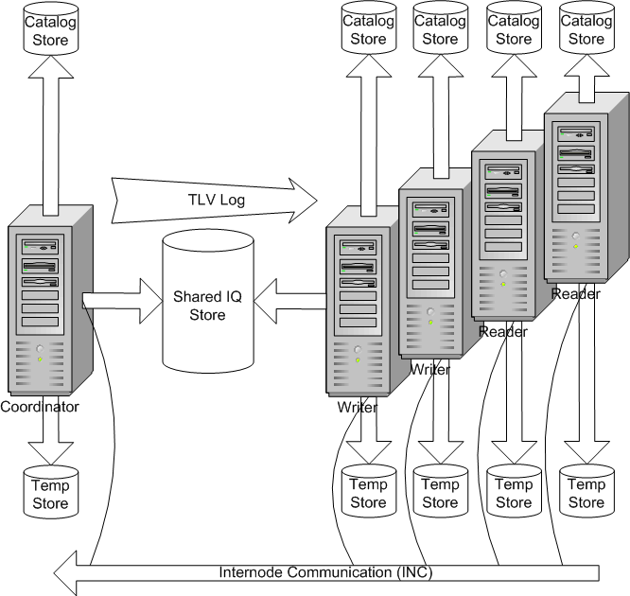

The coordinator node has its own catalog and temporary store. It shares an IQ store with writer and reader nodes that each have their own catalog and temporary store. The coordinator writes a TLV log that tells readers and writers about changes. Readers and writers pass information to the coordinator using Internode Communications (INC).

Each server has its own temporary store and catalog store.

The shared IQ store is common to all servers.

**Scalability**

Sybase IQ’s patented design permits databases to scale to contain many terabytes of data.

Its index-based structure allows IQ to store your data in a much smaller space than the size of the raw input data, and access it far faster than a traditional relational database. These features make Sybase IQ ideal for storing and accessing very large databases (VLDBs).

Database administrators need to understand the options and features that affect performance, and follow documented guidelines. While many default settings automatically provide the greatest efficiency, you may need to experiment with certain option settings for the fastest results, based on your configuration, your loading requirements, and your queries. Setting these options appropriately is necessary for top performance in any Sybase IQ database, but is especially important as your database grows to the multiterabyte scale.

**Performance and Tuning**

**Performance and Tuning: Locking**

Adaptive Server locks the tables, data pages, or data rows currently used by active transactions by locking them. Locking is a concurrency control mechanism: it ensures the consistency of data within and across transactions. Locking is needed in a multiuser environment, since several users may be working with the same data at the same time.

Carefully considered indexes, built on top of a good database design, are the foundation of a high-performance Adaptive Server installation. However, adding indexes without proper analysis can reduce the overall performance of your system. Insert, update, and delete operations can take longer when a large number of indexes need to be updated.

**Performance and Tuning: Optimizer and Abstract Plans**

The Optimizer in the Adaptive Server takes a query and finds the best way to execute it. The optimization is done based on the statistics for a database or table. The optimized plan stays in effect until the statistics are updated or the query changes. You can update the statistics on the entire table or by sampling on a percentage of the data.

**Performance and Tuning: Monitoring and Analyzing**

Adaptive Server employs reports for monitoring the server. This manual explains how statistics are obtained and used for monitoring and optimizing. The stored procedure sp_sysmon produces a large report that shows the performance in Adaptive Server.

**Working**

The steps that you complete to configure a Sybase Enterprise stage depend on whether you use the stage to read, write, or lookup Sybase data. Before you configure the stage, ensure that column metadata is specified for the operation that you want to complete.

**Using Sybase open client**

The Sybase Enterprise stage libraries are compiled against OSC 12.5. For libraries to load and work correctly with OSC 15.0, run the script lnsyblibs.sh in the $SYBASE/OCS-15_0/scripts directory.

**Updating a Sybase database**

To update a Sybase database, you must specify values for the properties in the Target, Connection, and Option sections.

**Loading a Sybase database**

To load a Sybase database, you must specify values for the properties in the Target, Connection, and Option sections.

**Reading data from a Sybase database**

To read a Sybase database, you must specify appropriate values for the properties in the Source, Connection, and Option sections.

**Reading from a remote Sybase IQ server**

The Sybase Enterprise stage supports reading and writing operations on a remote Sybase IQ server.

Performing a lookup on a Sybase database

You perform a direct lookup or in-memory lookup on a Sybase database.